# **Green Design**

## **1 System prototype screens**

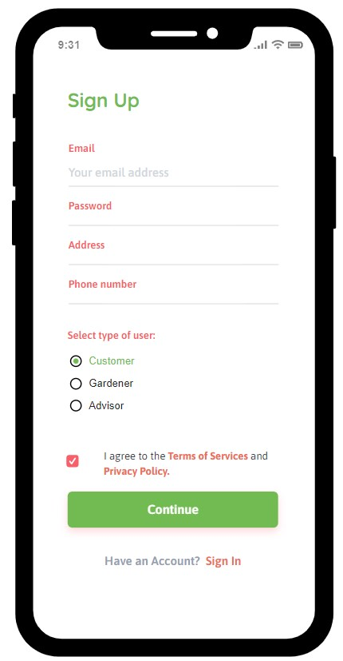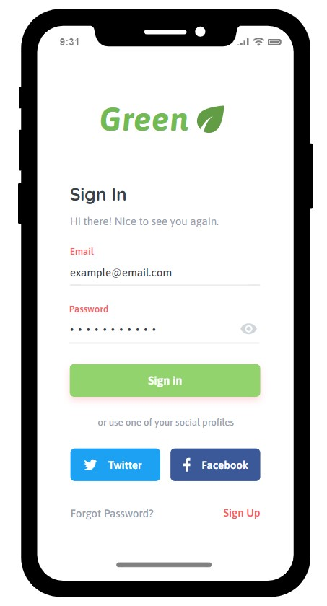**Login & Sign up.**

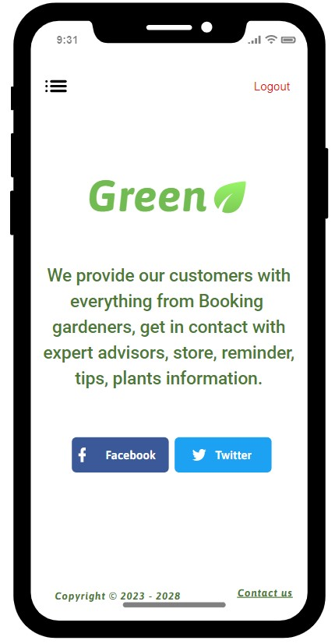**Home page & Menu.** **View Bookings.**

**Reminder page.** **Products.** **Tips.**

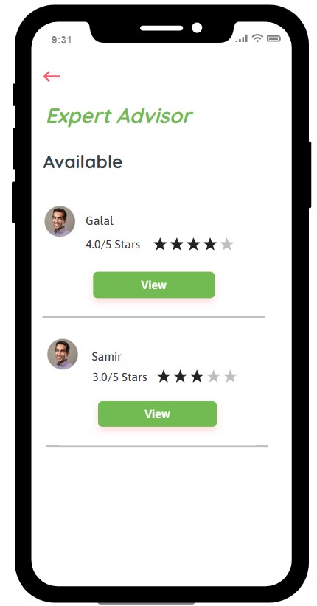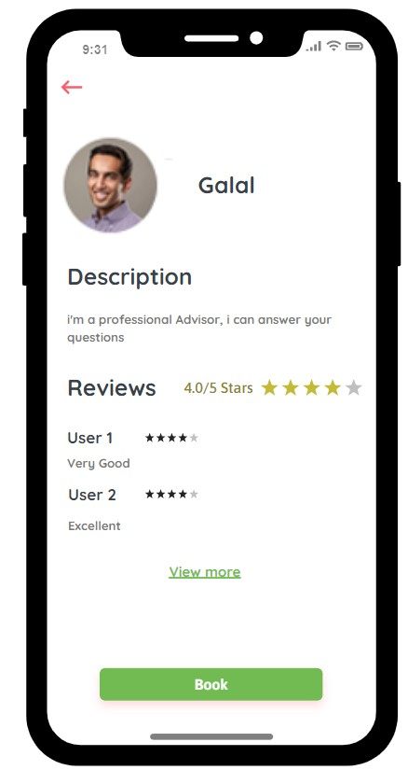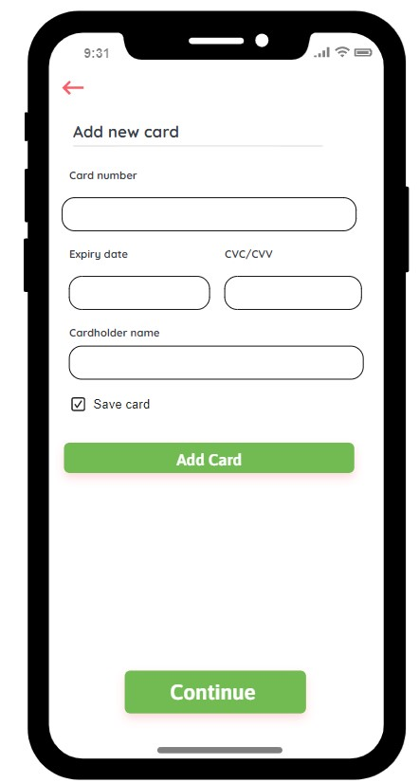**Booking Expert Advisor pages.**

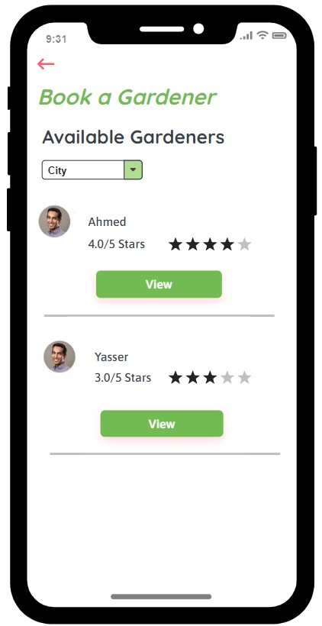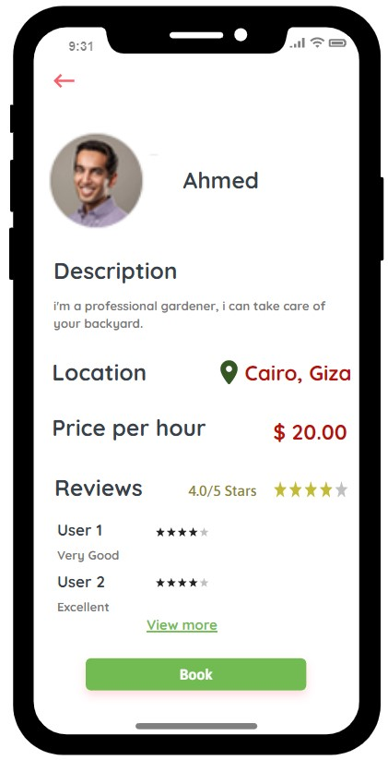**Booking Gardener pages.**

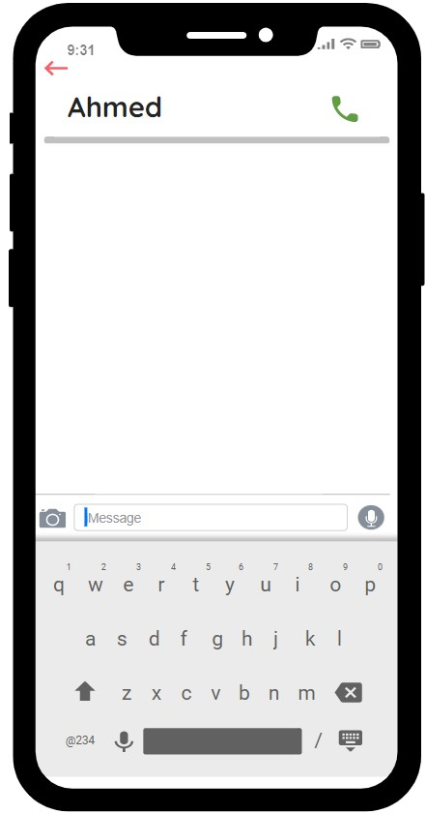

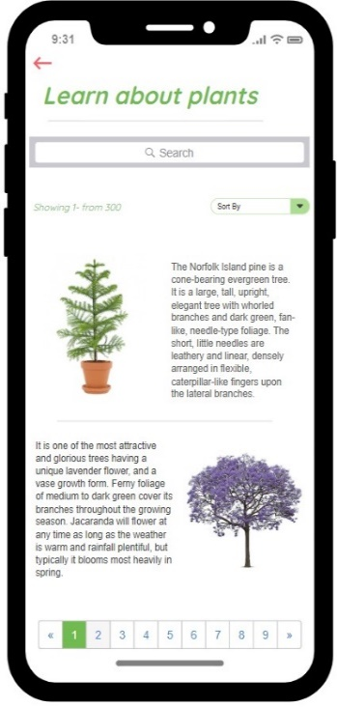**Learn about plants. Manage Profile.** **Expert** **Advisor pages**

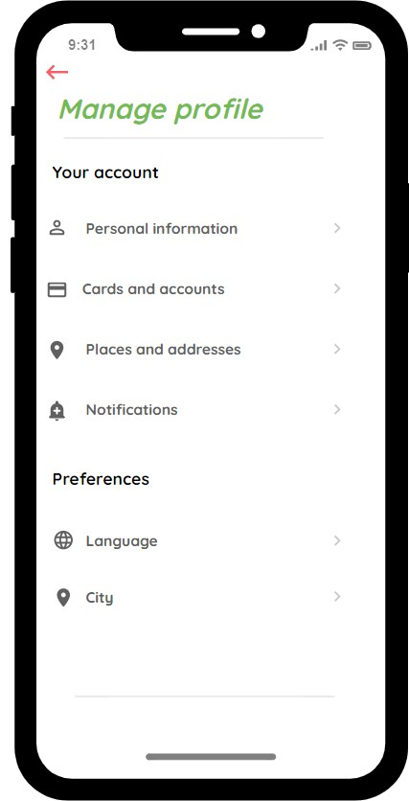

**Gardener**  **pages**. **Admin Panel.**